Practical: 6 | Implementation of chain matrix multiplication using dynamic programming
01/09/2026

Aim: To Implement the chain matrix multiplication using dynamic programming

Algorithm:

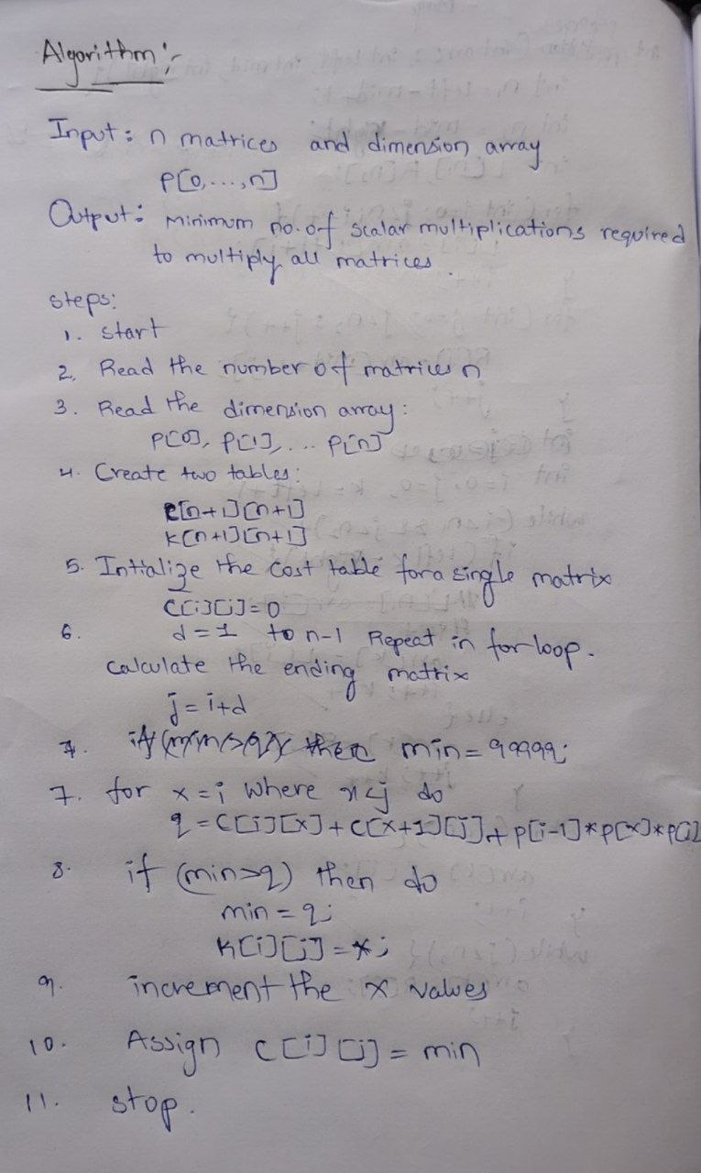
Program:

#include <iostream>
using namespace std;

int main(){
int n = 5;

int p[] = {5, 10, 3, 12, 5, 50};

int c[10][10] = {0};
int k[10][10] = {0};

for(int d = 1; d < n; d++){
for(int i = 1; i <= n-d; i++){
int j = i + d;
int min = 99999;

for(int x = i; x < j; x++){
int q = c[i][x] + c[x+1][j]
+ p[i-1] * p[x] * p[j];

if(q < min){
min = q;
k[i][j] = x;
}
}
c[i][j] = min;
}
}

cout << "\nMinimum cost = " << c[1][n]<<endl;

return 0;
}

Output:

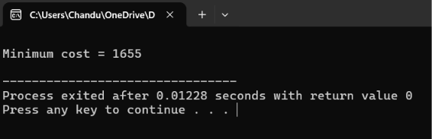

Time Complexity:

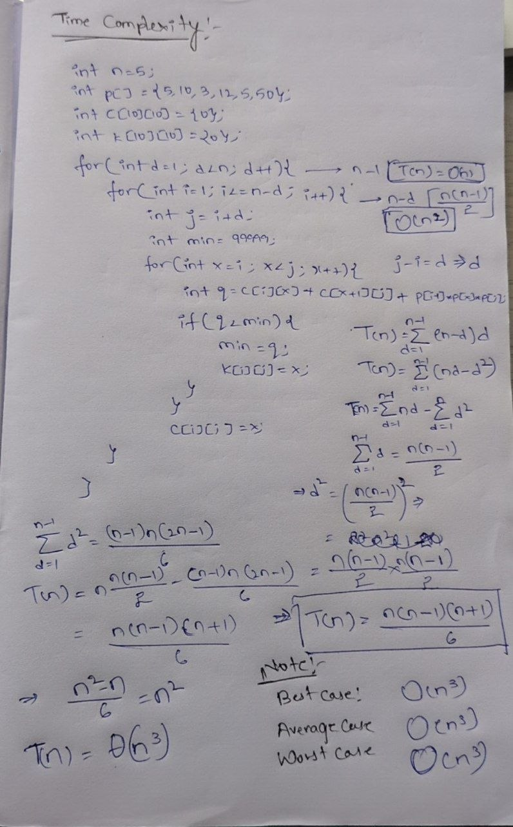

Conclusion:
The Implementation of the of chain matrix multiplication using dynamic programming has successfully executed with the time complexity of O(n^3) in the Three cases of best, average and worst. At the end of this program says that the Minimum number of scalar multiplications required to multiply all matrices.

